

American International University Bangladesh

##### **Project Title:**

##### School Management System

**Prepared for-**

**xxxx**

**Prepared by-**

|  |  |
| --- | --- |
| Name | ID |
| Zaman md sumsush | 14-27822-3 |
|  |  |
|  |  |

Table ofContents

Business and System summary: 2

Business Environment 2

Hardware: 2

Software: 2

Technical Summary 3

Project Objectives 3

ER Diagram: 4

Normalization: 5

Schema Diagram: 12

Table Description: 13

Showing Data: 16

Task: 19

Problem Faced: 23

Project Learning Experienced 23

Lesson Learned: 23

Software & Future Plan: 23

# Business and System summary:

School management system has been designed to make an new era for our developing nation. It will help us to store the data of student, teacher as well as admin and school information. Not only that in near future by developing the system we can expand the database and work for the welfare for the education system of our nation. By managing this kind of data we can easily run a school system without any hardship or facing complicated issues. If we have to keep and maintain those data in a hardcopy or in a written papers then it will be more difficult to maintain the data and we will face a lot of security issues but if we came to a database system then it will be easy for us to cope up with this kind of complications.

# Business Environment

The project School Management Database System (SMDS) in based on database and oriented techniques. As there are many areas where we keep records in database, for which we using ORACLE 10g Express Edition software that is one of the best and easiest software to keep information. In this project, we use C# as the front and which is a Object Oriented Programming Language. It is a web connectivity based application in which many user can access it through a server at a time.

### Hardware:

Processor : Intel Core 2 Duo

Memory : 2 GB RAM

Cache Memory : 5 MB

### Software:

Operating System: Windows 7(professionals)

Front-End-Tool: C#

Back-End : Oracle 10g

# Technical Summary

School Management Database System is database system where we can store all in information of data. Every student is identify uniquely through there student id and every student has a class teacher through teacher id we can know this. Besides, teacher id is representing every teacher uniquely. As teacher and student, every single person who worked in a school can identify through only a number and this number is unique. Moreover, class room, lab, department, building everything is here identifying through a unique number. Through this unique number,any one can access relationship between two of any one. This makes this system very efficient system. When we make some update or modify we only use that unique number through this we required to change in a one portion than it will automatically change all over. And this database system has some advanced option that removes the problem of some mistake like when u put any information but it is not appropriate for this column than this database system will deny the entry. Through this we reduce many of redundancy.

### Project Objectives

This project is for the introduction to the school management system. It is the computerized system of storing student teacher and admins information . It has made the process of storing students, teachers, admin and schools data so much easier than ever imagined. In our country there are thousands of school. It is very difficult to maintain the hand writing document but using this system we can easily store information . This system also provide excellent security of data and provide reliable storage and backup facilities.

# ER Diagram:

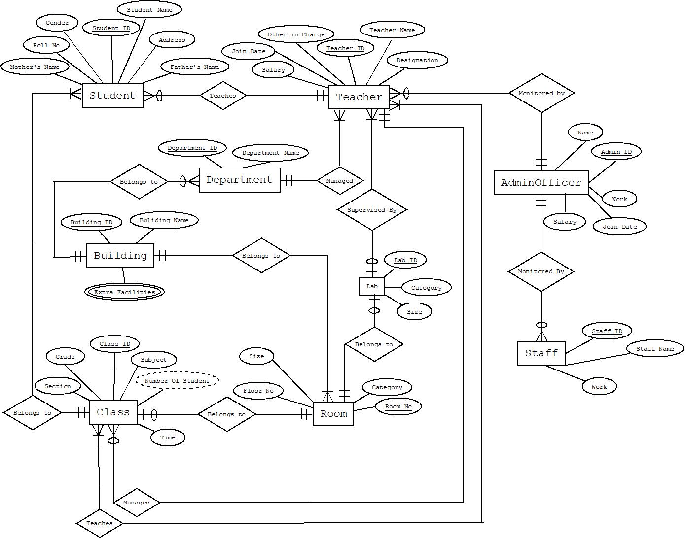

# Normalization:

**Monitored By(Admin_0fficer & Staff):**

|  |  |  |  |  |  |  |  |
| --- | --- | --- | --- | --- | --- | --- | --- |
| Admin_id | Name | Work | Salary | JoinDate | Staff_id | Name | work |

**1NF:**

|  |  |  |  |  |  |  |  |
| --- | --- | --- | --- | --- | --- | --- | --- |
| AdminOfficer_id | AdminOfficer_  Name | AdminOfficer_  Work | AdminOfficer_  Salary | AdminOfficer_  JoinDate | Staff_id | Staff_  Name | Staff_  work |

**2NF:**

**Table: Admin_Officer**

|  |  |  |  |  |
| --- | --- | --- | --- | --- |
| AdminOfficer_id | AdminOfficer_Name | AdminOfficer_Work | AdminOfficer_Salary | AdminOfficer_  JoinDate |

**Table: Staff**

|  |  |  |  |
| --- | --- | --- | --- |
| Staff_id | Staff_Name | Staff_work | AdminOfficer_id |

**Belongs to (Building & Department):**

|  |  |  |  |  |
| --- | --- | --- | --- | --- |
| Building_id | Building_name | Extra_facilities | Department_id | Department_name |

**1NF:**

|  |  |  |  |
| --- | --- | --- | --- |
| Building_id | Building_name | Department_id | Department_name |

Extra_Facilities

|  |  |
| --- | --- |
| Building_id | Facilities |

**2NF:**

**Table: Department**

|  |  |  |
| --- | --- | --- |
| Department_id | Department_name | Building_id |

**Table: Building**

|  |  |
| --- | --- |
| Building_id | Building_name |

**Table: Extra_Facilities**

|  |  |
| --- | --- |
| Building_id | Facilities |

**Belongs to (Buidling & Room):**

|  |  |  |  |  |  |  |
| --- | --- | --- | --- | --- | --- | --- |
| Building_id | Building_name | Extra_Facilities | Room_no | Size | Category | Floor_no |

**1NF:**

|  |  |  |  |  |  |
| --- | --- | --- | --- | --- | --- |
| Building_id | Building_name | Room_no | Room_size | Room_category | Floor_no |

Extra_Facilities

|  |  |
| --- | --- |
| Building_id | Facilities |

**2NF:**

**Table: Building**

|  |  |
| --- | --- |
| Building_id | Building_name |

**Table: Room**

|  |  |  |  |  |
| --- | --- | --- | --- | --- |
| Room_no | Room_size | Room_category | Floor_no | Building_id |

**Table: Extra_Facilities**

|  |  |
| --- | --- |
| Building_id | Facilities |

**Managed (Teacher & Department):**

|  |  |  |  |  |  |  |  |
| --- | --- | --- | --- | --- | --- | --- | --- |
| Department_id | Department_name | Teacher_id | Teacher_name | Salary | Designation | Other_incharge | JoinDate |

**1NF:**

|  |  |  |  |  |  |  |  |
| --- | --- | --- | --- | --- | --- | --- | --- |
| Department_  id | Department_  name | Teacher_  id | Teacher_  name | Teacher_  salary | Designation | Other_incharge | Teacher_  JoinDate |

**2NF:**

**Table: Department**

|  |  |
| --- | --- |
| Department_id | Department_name |

**Table: Teacher**

|  |  |  |  |  |  |  |
| --- | --- | --- | --- | --- | --- | --- |
| Teacher_id | Teacher_name | Teacher_salary | Designation | Other_in_charge | Teacher_JoinDate | Department_id |

**Supervised By (Teacher & Lab):**

|  |  |  |  |  |  |  |  |  |
| --- | --- | --- | --- | --- | --- | --- | --- | --- |
| Teacher_id | Teacher_name | Salary | Designation | Other_in_charge | JoinDate | Lab_id | Size | Category |

**1NF:**

|  |  |  |  |  |  |  |  |  |
| --- | --- | --- | --- | --- | --- | --- | --- | --- |
| Teacher_  id | Teacher_  name | Teacher_  salary | Designation | Other_in_charge | Teacher_  JoinDate | Lab_id | Lab_size | Lab_  category |

**2NF:**

**Table: Teacher**

|  |  |  |  |  |  |
| --- | --- | --- | --- | --- | --- |
| Teacher_id | Teacher_name | Teacher_salary | Designation | Other_in_charge | Teacher_JoinDate |

**Table: Lab**

|  |  |  |
| --- | --- | --- |
| Lab_id | Lab_size | Lab_category |

**Belongs to (Lab & Room):**

|  |  |  |  |  |  |  |
| --- | --- | --- | --- | --- | --- | --- |
| Room_no | Size | Category | Floor_no | Lab_id | Size | Category |

**1NF:**

|  |  |  |  |  |  |  |
| --- | --- | --- | --- | --- | --- | --- |
| Room_no | Room_size | Room_category | Floor_no | Lab_id | Lab_size | Lab_category |

**2NF:**

**Table: Room**

|  |  |  |  |
| --- | --- | --- | --- |
| Room_no | Room_size | Room_category | Floor_no |

**Table: Lab**

|  |  |  |  |
| --- | --- | --- | --- |
| Lab_id | Lab_size | Lab_category | Room_no |

**Belongs to (Class & Room):**

|  |  |  |  |  |  |  |  |  |  |
| --- | --- | --- | --- | --- | --- | --- | --- | --- | --- |
| Class_id | Grade | Section | Subject | Time | Numberofstudent | Room_no | Size | Category | Floor_no |

**1NF:**

|  |  |  |  |  |  |  |  |  |  |
| --- | --- | --- | --- | --- | --- | --- | --- | --- | --- |
| Class_id | Grade | Section | Subject | Time | Numberofstudent | Room_  no | Room_  size | Room_  category | Floor_no |

**2NF:**

**Table: Class**

|  |  |  |  |  |  |  |
| --- | --- | --- | --- | --- | --- | --- |
| Class_id | Grade | Section | Subject | Time | Numberofstudent | Room_no |

**Table: Room**

|  |  |  |  |
| --- | --- | --- | --- |
| Room_no | Room_size | Room_category | Floor_no |

**Teaches (Student &Teacher):**

|  |  |  |  |  |  |  |  |  |  |  |  |  |
| --- | --- | --- | --- | --- | --- | --- | --- | --- | --- | --- | --- | --- |
| Student_  id | Student_  name | Gender | Address | Father_  name | Mother_  name | Roll_  no | Teacher_  Id | Teacher_  name | Salary | Other_in_  charge | Designation | Joindate |

|  |  |  |  |  |  |  |  |  |  |  |  |  |
| --- | --- | --- | --- | --- | --- | --- | --- | --- | --- | --- | --- | --- |
| Student_  id | Student_  name | Gender | Address | Father_  name | Mother_  name | Roll_  no | Teacher_  id | Teacher  _  name | Teacher_  Salary | Other_  in_  charge | Designation | Teacher_  Join  date |

**1NF:**

**2NF:**

**Table: Student**

|  |  |  |  |  |  |  |  |
| --- | --- | --- | --- | --- | --- | --- | --- |
| Student_id | Student_name | Gender | Address | Father_name | Mother_name | Roll_no | Teacher_id |

|  |  |  |  |  |  |
| --- | --- | --- | --- | --- | --- |
| Teacher_id | Teacher_name | Teacher_Salary | Other_in_charge | Designation | Teacher_Joindate |

**Table: Teacher**

**Belongs to (Class & Student):**

|  |  |  |  |  |  |  |  |  |  |  |  |  |
| --- | --- | --- | --- | --- | --- | --- | --- | --- | --- | --- | --- | --- |
| Student_  id | Student_  name | Gender | Address | Father_  name | Mother_  name | Roll_  no | Class_  id | Grade | Section | Sunject | Time | Num  Of  student |

**1NF:**

|  |  |  |  |  |  |  |  |  |  |  |  |  |
| --- | --- | --- | --- | --- | --- | --- | --- | --- | --- | --- | --- | --- |
| Student_  id | Student_  name | Gender | Address | Father_  name | Mother_  name | Roll_  no | Class_  id | Grade | Section | Sunject | Time | Num  Of  student |

**2NF:**

**Table: Student:**

|  |  |  |  |  |  |  |  |
| --- | --- | --- | --- | --- | --- | --- | --- |
| Student_id | Student_name | Gender | Address | Father_name | Mother_name | Roll_no | Class_id |

**Table: Class**

|  |  |  |  |  |  |
| --- | --- | --- | --- | --- | --- |
| Class_id | Grade | Section | Sunject | Time | Numberofstudent |

**Managed (Class & Teacher):**

|  |  |  |  |  |  |  |  |  |  |  |  |
| --- | --- | --- | --- | --- | --- | --- | --- | --- | --- | --- | --- |
| Class_  id | Grade | Section | Time | NumOf  Student | Subject | Teacher_  id | Teacher_  Name | Designation | Salary | Join_  Date | Other_  in_  charge |

**1NF:**

|  |  |  |  |  |  |  |  |  |  |  |  |
| --- | --- | --- | --- | --- | --- | --- | --- | --- | --- | --- | --- |
| Class_  id | Grade | Section | Time | NumOf  Student | Subject | Teacher_  id | Teacher_  name | Designation | Teacher_  salary | Teacher_  Join  date | Other_  in_  charge |

**2NF:**

**Table: Class**

|  |  |  |  |  |  |  |
| --- | --- | --- | --- | --- | --- | --- |
| Class_id | Grade | Section | Time | Numberofstudent | Subject | Teacher_id |

**Table: Teacher**

|  |  |  |  |  |  |
| --- | --- | --- | --- | --- | --- |
| Teacher_id | Teacher_name | Designation | Teacher_salary | Teacher_JoinDate | Other_in_charge |

**Teaches (Class & Teacher):**

|  |  |  |  |  |  |  |  |  |  |  |  |
| --- | --- | --- | --- | --- | --- | --- | --- | --- | --- | --- | --- |
| Class_  id | Grade | Section | Time | NumOf  Student | Subject | Teacher_  id | Teacher_  Name | Designation | Salary | Join_  Date | Other_  in_  charge |

**1NF:**

|  |  |  |  |  |  |  |  |  |  |  |  |
| --- | --- | --- | --- | --- | --- | --- | --- | --- | --- | --- | --- |
| Class_  id | Grade | Section | Time | NumOf  Student | Subject | Teacher_  id | Teacher_  name | Designation | Teacher_  salary | Teacher_  Join  date | Other_  in_  charge |

**2NF:**

**Table: Class**

|  |  |  |  |  |  |
| --- | --- | --- | --- | --- | --- |
| Class_id | Grade | Section | Time | Numberofstudent | Subject |

**Table: Teacher**

|  |  |  |  |  |  |
| --- | --- | --- | --- | --- | --- |
| Teacher_id | Teacher_name | Designation | Teacher_salary | Teacher_JoinDate | Other_in_charge |

**Table: Teacher_Class**

|  |  |
| --- | --- |
| Teacher_id | Class_id |

# Schema Diagram:

Staff

1.Staff_id

2.Staff_name

3.Staff_work

4.Admin_id

Admin_Officer

1.Adminofficer_id

2.Adminofficer_name

3.Adminofficer_salary

4.Adminofficer_joidate

5Adminofficer_work

Department

1.Department_id

2.Department_name

3.Building_no

Room

1.Room_id

2.Room_size

3.Room_category

4.Building_no

5.Floor_no

Lab

1.Lab_id

2.Lab_category

3.Lab_size

4.Room_no

5.Teacher_id

Teacher

1.Teachr_id

2.Teacher_name

3.Teacher_salary

4.teacher_joindate

5.Designation

6.Other_in_charge

7.Manger_id

8.Department_id

Building

1.Building_id

2.Building_name

Student

1.Student_id

2.Student_name

3.Roll_no

4.Fathers_name

5.Mothers_name

6.Address

7.Teacher_id

8.Class_id

9.Gender

Class

1.Class_id

2.Grade

3.Section

4.Teacher_id

5.Number_of_student

6.Time

7.Subject

8.Room_no

# Table Description:

desc student;

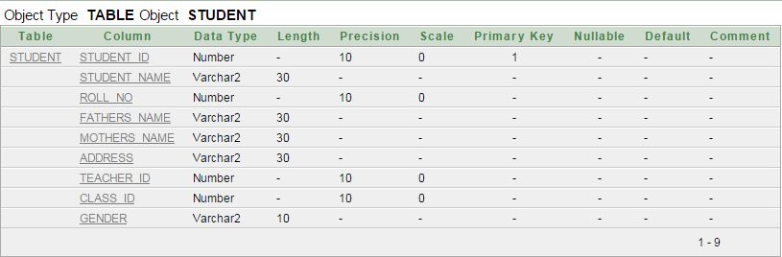

desc teacher;

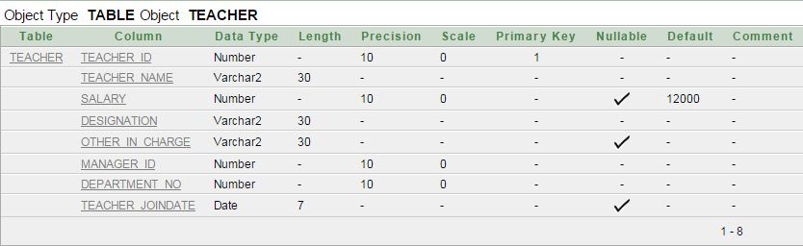

desc admin_officer;

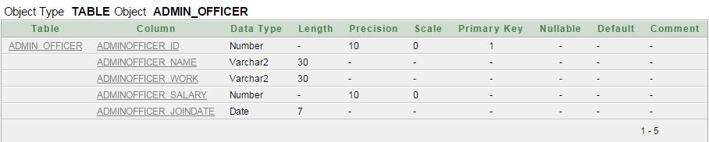

desc staff;

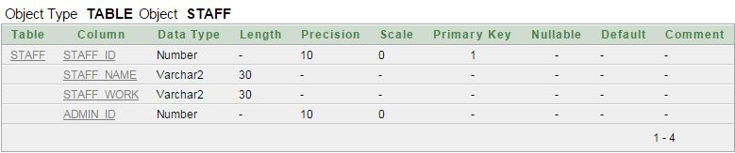

desc building;

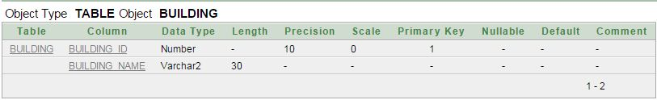

desc lab;

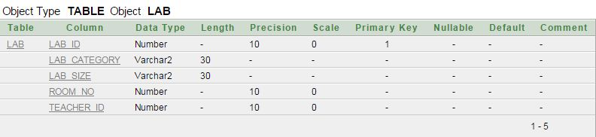

desc room;

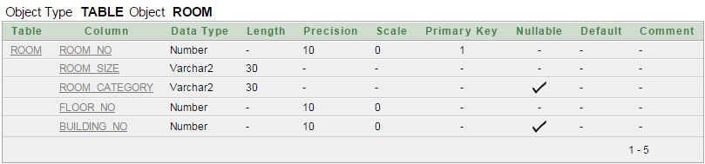

desc class;

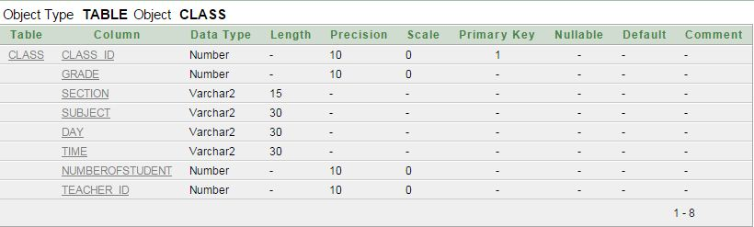

desc department;

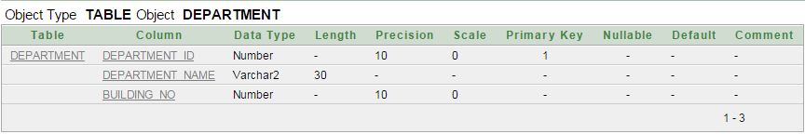

desc teacher_class;

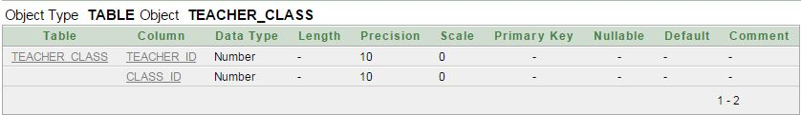

descextra_facilities;

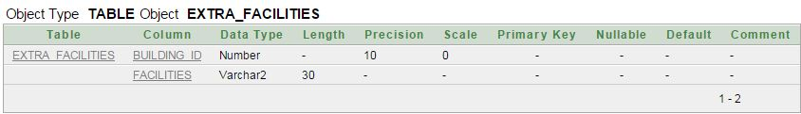

# Showing Data:

Select *from student

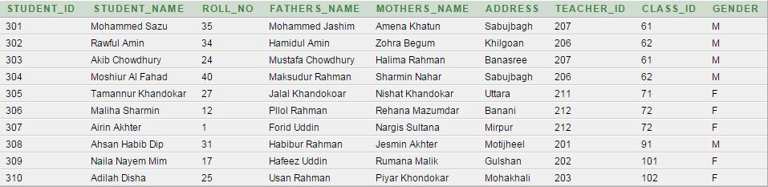

Select *from teacher

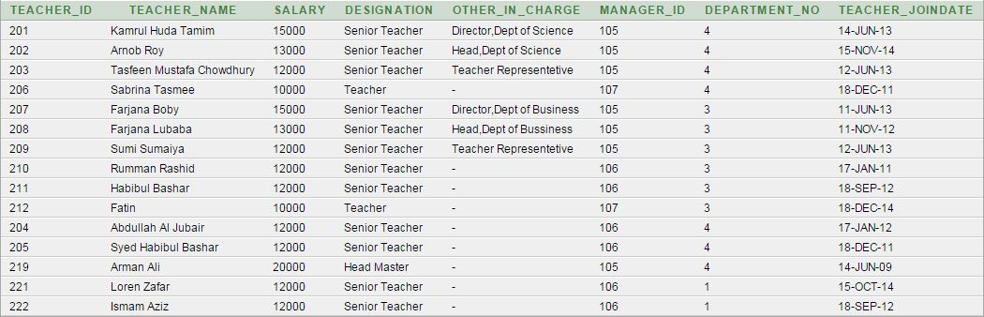

Select *from admin_officer;

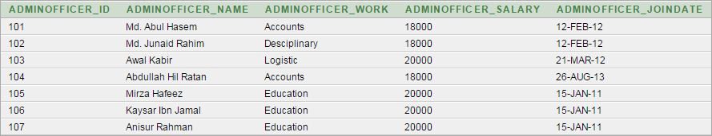

Select *from staff;

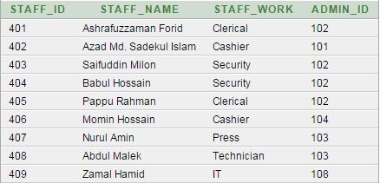

Select *from department;

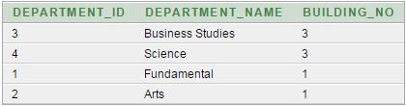

Select *from building;

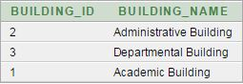

Select *from room;

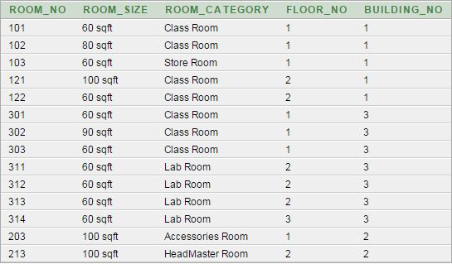

Select *from class;

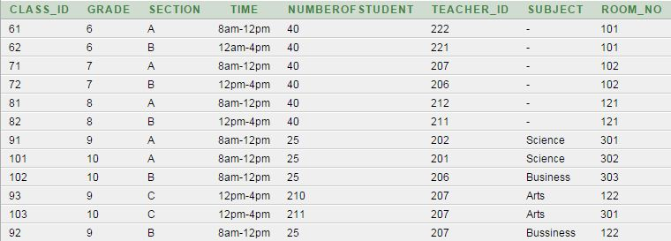

Select *from lab;

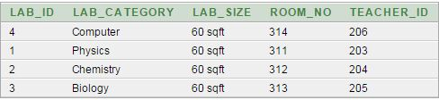

Select *from teacher_class;

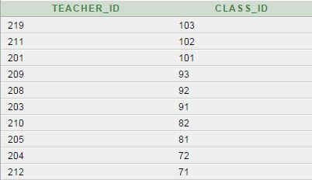

Select *from extra_facilities;

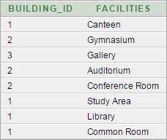

# Task:

select s.student_name,c.grade,c.section,c.time from student s,class c where c.grade=6 and c.class_id=s.class_id;

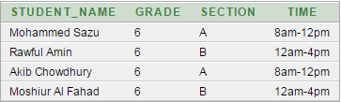

select s.student_name,c.grade,c.section,c.time,r.room_no from student s,class c,room r where c.grade=7 and c.class_id=s.class_id and c.room_no=r.room_no;

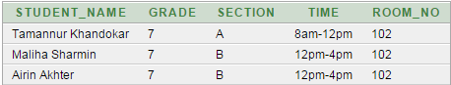

select b.building_name,r.room_no,c.time from building b,room r,class c,teacher t,teacher_class p where t.teacher_name in('Arnob Roy','Farjana Boby') and p.teacher_id=t.teacher_id and p.class_id=c.class_id and c.room_no=r.room_no and r.building_no= b.building_id;



select max(salary) from teacher group by designation having max(salary)>12000;

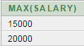

select d.department_name,t.teacher_name from teacher t,department d,building b where b.building_name in('Academic Building','Departmental Building’) and d.department_id =t.department_no and b.building_id=t.building_no;

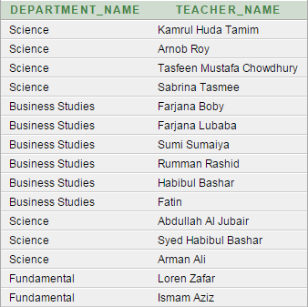

select designation,count(teacher_id) from teacher group by designation;

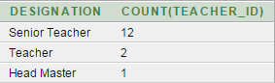

select other_in_charge,max(salary) from teacher group by other_in_charge;

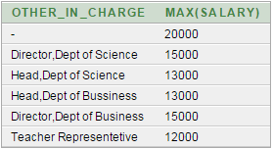

select adminofficer_id,adminofficer_name,adminofficer_joindate,adminofficer_salary from admin_officer where adminofficer_joindate <'1-Jan-2012';

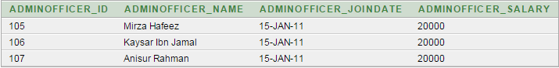

select s.student_name,t.teacher_name,a.adminofficer_name from teacher t,admin_officer a,student s where a.adminofficer_id=107 and s.teacher_id=t.teacher_id and t.manager_id= a.adminofficer_id;

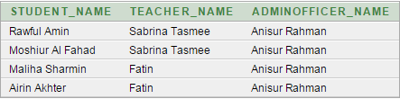

select b.building_id,k.facilities from building b, extra_facilities k where k.building_id= b.building_id;

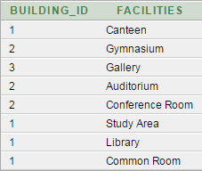

select lab_category , room_no from lab where lab_category in(‘Computer’,’Biology’);

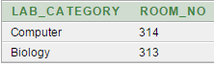

# Problem Faced:

During creation of this database project naturally there were some problems. Due to inexperience,we often faced difficulty to use our time effectively. to complete database relationship diagramclearly showing every table ,attributes and data type were another tough task to complete .Thenthere are some problems regarding table creation. Some simple mistakes often made it difficult tocreate the required tables. Despite our best effort, there might be some fault in our developeddatabase. We hope to learn from our mistake and apply the knowledge that we gained from thisproject in the future to create more professional database.

# Project Learning Experienced

## Lesson Learned:

In this project, we learned how to make a table, relationship diagrams and clearly presenting every table,attributes, and data type in this project. We also learned how can show data from table and how to add constraint. Besides faced some challenging task like convert case study into a entity relationship diagram, normalization, creating appropriate table, inserting value as well as.

## Software& Future Plan:

This project was developed to fulfill some requirement .However there are a lots of scope to improve the performance of this management system. Adding some extra features like calculating marks, student’s attendance, teacher’s punctuality many more we have that type plan. Besides, we have master plan that is providing VUES database for every student, teacher

and also admin. We are hopeful about our project.